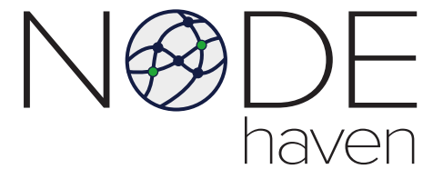



MICHAEL BAZZI

CO-FOUNDER OF NODE HAVE

Northville, Michigan

<https://www.linkedin.com/in/mibazzi/>

NODE Haven

NODE Haven, a US-based blockchain hardware manufacturer, provides everyone the ability to have the same advantages miner manufacturers have themselves: First access to advanced miners with a price based on cost of production. This is accomplished by following a co-operative model that utilizes an Ethereum ERC20 Token (NODE). NODE tokens may be used repeatedly to obtain miners at a price based on cost rather than market, significantly increasing the miner's ROI especially in times of high-demand.

